|  |
| --- |
| Photo displaying partial image of two pie charts on a canvas-textured page |
| Advanced Development System Group Assignment |
| |  |  |  | | --- | --- | --- | | ... | … | … | |

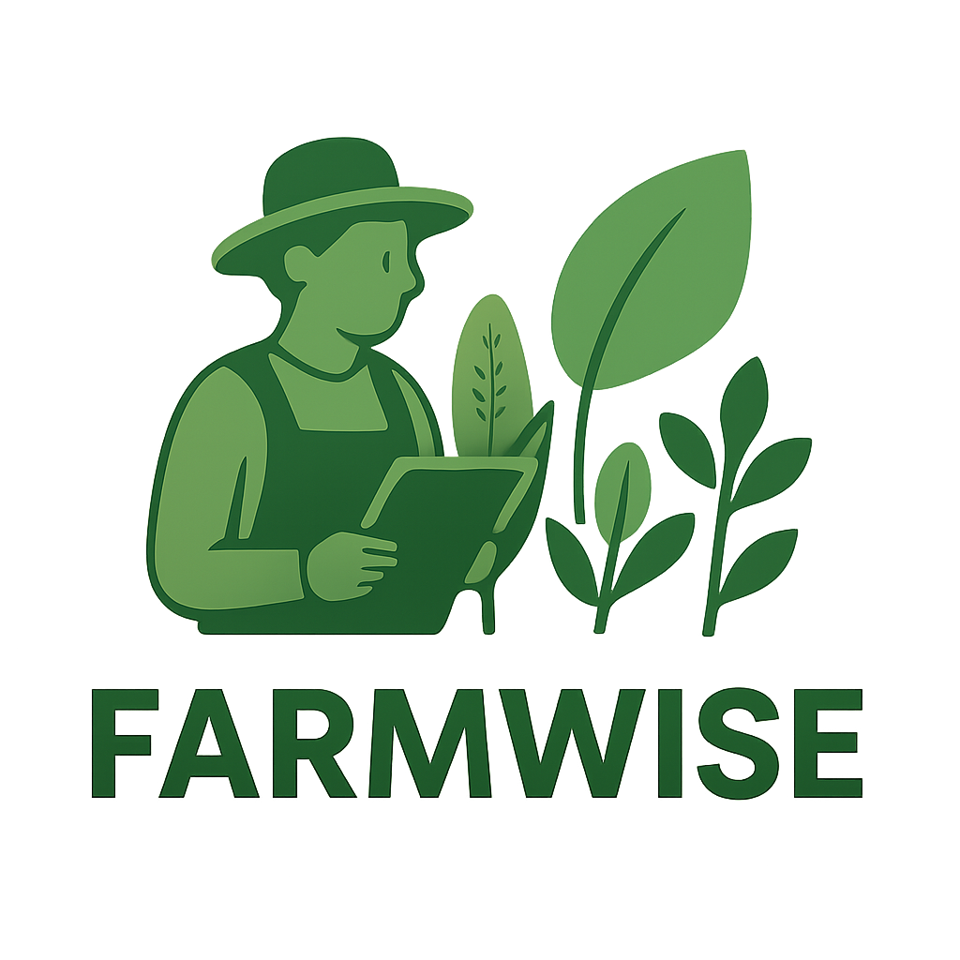

## Group Members

|  |  |
| --- | --- |
| Student Names | Student Number |
| Nkoana Hope Lerato | 202204804 |
| Mawela Mpho Precious | 202233722 |
| Khalo Ayanda Girly | 202213324 |
| Dlamini Kelebogile Sylvia | 202224253 |



## Problem Definition

**1.Problem Statement**

Agriculture in South Africa is highly vulnerable to the effects of climate change. Farmers face unpredictable weather patterns, including sudden rainfall, droughts, frost, and heatwaves, which directly affect crop yields and farm income (Olabanji, Ndarana & Davis, 2021). This challenge is particularly acute for farmers who own multiple farms in different regions, as each location experiences unique weather conditions. Without timely, accurate, and localized weather information, farmers risk planting crops that may fail, wasting resources such as seeds, fertilizers, and water, and ultimately suffering economic losses (Kephe, Ayisi & Petja, 2021).

Climate change poses a significant threat to South African agriculture, which depends heavily on rainfall and stable weather conditions. Research indicates that rising temperatures and declining rainfall will reduce crop yields by up to 65% for maize, with similar reductions for other essential crops such as soya beans and dry beans (Olabanji, Ndarana & Davis, 2021). This uncertainty in agricultural planning contributes to reduced productivity, financial hardship, and increased food insecurity in rural communities.

**Solution**

To mitigate these challenges, a **Smart Weather Advisory System** will be developed. The system will serve as a **web-based agricultural decision-support platform** that empowers farmers with data-driven insights. Key features include:

* **Real-time weather forecasts:** Integration with the OpenWeatherMap REST API to provide location-specific weather updates and predictions.
* **Crop recommendations:** Suggestions based on soil type, regional climate, and forecasted conditions.
* **Planting calendars:** Automated schedules to guide farmers on optimal sowing and harvesting times.
* **Pest database:** Information on potential pests linked to specific crops and soil conditions, with management strategies.
* **AI-powered chatbot:** A conversational tool that provides farmers with tailored planting advice, pest management tips, and answers to agricultural queries.
* **Garden Journal:** A record-keeping feature that allows farmers to track planting activities, monitor growth progress, and compare seasonal outcomes.

By integrating real-time weather data, predictive charts, pest control information, and AI-driven guidance, the system addresses the critical information gap faced by farmers. It reduces uncertainty in decision-making, prevents resource waste, and improves both crop productivity and resilience to climate variability. The platform will also enhance farmers’ ability to plan across multiple farms, helping to secure livelihoods and strengthen food security in South Africa.

**2. Why It Matters in ICT**

ICT offers innovative solutions to mitigate the challenges posed by climate change in agriculture. Through technologies such as weather APIs, data analytics, and mobile/web applications, farmers can make informed decisions based on real-time weather updates and crop recommendations. By leveraging ICT, farmers gain access to **location-specific forecasts**, helping them adapt planting schedules and select suitable crops for each region (FAO, 2019).

Additionally, ICT-based solutions support the adoption of **climate-smart agricultural practices**, which are essential for sustainability and resilience in the agricultural sector (Kephe, Ayisi & Petja, 2021). Developing such applications aligns with global efforts to digitize agriculture and strengthen food security through technological innovation.

This problem matters in ICT because technology can play a **transformative role** in agriculture, one of South Africa’s largest employment sectors. ICT enables:

* **Service-Oriented Architecture (SOA):** The system can be built as modular services (e.g., weather service, pest detection service, calendar service) that communicate independently. For example, the weather module fetches data from OpenWeatherMap, while the pest module queries a local database. Each can be reused or extended without disrupting others.
* **REST APIs:** Allow integration with external data providers. For example, GET requests can fetch weather forecasts in JSON format, which can then be transformed into user-friendly charts and visualizations for farmers.
* **Git and GitHub for Collaboration:** Git provides version control, allowing multiple developers to collaborate effectively. GitHub ensures real-time backups and smooth team coordination.
* **Practical ICT Solutions:** This project demonstrates how **data science, web development, and APIs** can be combined to tackle **real-world issues in food security and climate resilience**.

**3.Plan, Resources, and Tools**

**1. Website Structure & Features**

* **Home Page** – Provides an overview of the platform, its purpose, and how it supports farmers.
* **Selection Page** – Users input knowledge about farming, soil type, and crops they want to grow.
* **REST API Data Analysis** – Uses external APIs to display weather predictions, soil insights, and pest control data with charts and visualizations.
* **Sign Up & Login** – Secure authentication for farmers to access personalized features.
* **Weather Dashboard** – Real-time, location-based weather updates via **OpenWeatherMap API**. Provides crop suggestions based on soil and climate conditions. For example, if conditions are suitable for tomatoes, a “growth table” is shown.
* **Planting Calendar** – Displays planting and harvesting schedules based on local climate data.
* **Pest Database** – Shows pests and diseases linked to specific crops and soil types, with prevention tips.
* **AI Chatbot** – An interactive assistant where users ask planting tips, crop care, or general farming questions.
* **Garden Journal** – Allows users to record farming activities and track crop growth over time.

**2. Key Features & Functional Modules**

* **Weather Updates:** Real-time forecasts (temperature, rainfall, humidity) from **OpenWeatherMap API**.
* **Crop Advisory System:** Suggests crops based on soil type + weather predictions.
* **Pest & Disease Alerts:** Provides region-specific pest warnings using agricultural databases.
* **Farming Calendar:** Notifies users when to plant or harvest based on climatic conditions.
* **Data Dashboard:** Graphs and charts for weather trends, soil data, and pest alerts, making data more understandable.

**3. Tools, Resources, and Technologies**

* **Frontend Development:**
  + **HTML, CSS, JavaScript** → For designing a user-friendly interface.
  + **React.js or Vue.js** → For building interactive dashboards and chatbot integration.
* **Backend Development:**
  + **Django / Flask (Python)** → To handle user authentication, API integration, and logic for crop advisory.
  + **RESTful APIs** → For communication between system components.
* **Databases:**
  + **PostgreSQL / MySQL** → To store user details, journal records, pest database, and crop information.
* **External APIs & Data Sources:**
  + **OpenWeatherMap API** → For weather forecasts.
  + **Soil & Agricultural Databases** → For soil type classification and pest/disease data.
  + **GitHub / GitLab** → For source code management and version control.
* **AI & Chatbot Tools:**
  + **Dialogflow / Rasa / Custom NLP with Python** → To build the AI chatbot for farming queries.
* **Visualization Tools:**
  + **Chart.js / D3.js / Matplotlib (Python)** → To create user-friendly graphs and dashboards.
* **Version Control & Collaboration:**
  + **Git + GitHub** → To manage project versions and team contributions.



## Reference

* Olabanji, M.F., Ndarana, T. & Davis, N. (2021) *Impact of Climate Change on Crop Production and Potential Adaptive Measures in the Olifants Catchment, South Africa.* Department of Geography, Geo-informatics and Meteorology, University of Pretoria.
* Kephe, P.N., Ayisi, K.K. & Petja, B.M. (2021) *Challenges and Opportunities in Crop Simulation Modelling under Seasonal and Projected Climate Change Scenarios for Crop Production in South Africa.* Agricultural & Food Security, 10(10), pp. 1–14.
* FAO (2019) *Climate-Smart Agriculture Sourcebook.* Food and Agriculture Organization of the United Nations.